WEEK 2 INTERNSHIP REPORT
Data Visualization and Insight Communication using R
Spotify Most Streamed Songs 2025 Dataset

Intern | Bala Gayatri
Internship | YuvaIntern – NSDC
Week | Week 2
Technology | R / RStudio (Posit Cloud)
Dataset | Most Streamed Spotify Songs 2025

- Executive Summary
This report presents the Week 2 internship work completed under the YuvaIntern program with a focus on data visualization and insight communication using R. The Most Streamed Spotify Songs 2025 dataset used in Week 1 was continued so that the visualization stage could build directly on the previously cleaned and explored data. The objective of this week was to create informative visualizations, select appropriate chart types, explain their significance, and communicate analytical findings in a form understandable to both technical and non-technical audiences. Using R, ggplot2, and base plotting functions, multiple visualizations were developed to examine song popularity, artist representation, streaming distributions, collaboration patterns, relationships between daily and total streams, and the concentration of streaming activity. The visual analysis reinforces important findings from Week 1, including the strong positive relationship between daily streams and total Spotify streams, the high representation of certain artists, and the relatively small proportion of collaborations. Each visualization is supported by R code, an output placeholder, an explanation of why the chart was selected, and an interpretation of the insight communicated.

- Contents
1. Executive Summary
2. Contents
3. Screenshot Checklist
4. Task Objective
5. Dataset Selection and Overview
6. Tools and Environment
7. Data Import and Initial Inspection
8. Data Cleaning
9. Data Preprocessing and Transformation
10. Exploratory Data Analysis
11. Correlation Analysis
12. Initial Findings and Insights
13. R Code Appendix
14. Conclusion

3. Screenshot Checklist

What the screenshot should show | Figure No. | Where to place it
Dataset imported in R / most_streamed_spotify_2025.csv visible in RStudio | Figure 1 | Section 7.1 – Importing the Dataset
Output of head(spotify) showing first few records | Figure 2 | Section 7.2 – Inspecting the First Records
Output of str(spotify) showing 730 observations and variables | Figure 3 | Section 7.3 – Checking Dataset Structure
Output of summary(spotify) | Figure 4 | Section 7.4 – Summary Statistics
Output of dim(spotify) and names(spotify) | Figure 5 | Section 7.5 – Dataset Dimensions and Column Names
Output of colSums(is.na(spotify)) | Figure 6 | Section 8.1 – Missing-Value Detection
RStudio output showing removal of wrapped_global_top10_rank | Figure 7 | Section 8.2 – Removing the High-Missingness Column
Output of sum(duplicated(spotify)) | Figure 8 | Section 8.3 – Duplicate Check
Second colSums(is.na(spotify)) after cleaning | Figure 9 | Section 8.4 – Missing Values After Cleaning
Boxplot of spotify_streams_total | Figure 10 | Section 9.1 – Outlier Detection
Boxplot of daily_streams | Figure 11 | Section 9.1 – Outlier Detection
Final str(spotify) after as.numeric() conversion | Figure 12 | Section 9.3 – Converting Scaled Columns to Numeric Vectors
Final str(spotify) after categorical encoding | Figure 13 | Section 9.4 – Encoding Categorical Variables
Histogram showing distribution of daily streams | Figure 14 | Section 10.1 – Daily Stream Distribution
Bar chart showing collaboration distribution | Figure 15 | Section 10.2 – Collaboration Distribution
Output/table showing the top 10 most-streamed songs | Figure 16 | Section 10.3 – Top 10 Most Streamed Songs
Output/table showing top 10 artists and their song counts | Figure 17 | Section 10.4 – Top 10 Artists by Number of Songs
Bar chart showing top 10 artists | Figure 18 | Section 10.5 – Top 10 Artists Visualization
Bar chart showing top 10 most-streamed songs | Figure 19 | Section 10.6 – Top 10 Songs Visualization
Scatter plot of daily streams vs total Spotify streams | Figure 20 | Section 10.7 – Daily Streams vs Total Streams
R output showing [1] 0.7795761 | Figure 21 | Section 11 – Correlation Analysis
Correlation matrix heatmap generated using corrplot | Figure 22 | Section 11.1 – Correlation Matrix and Heatmap

4. Task Objective
The objective of Week 1 was to develop practical skills in data cleaning, preprocessing and preliminary analysis using R. The work specifically focused on identifying data-quality issues, handling missing values, checking duplicates, detecting outliers, normalizing numerical variables, encoding categorical variables, and performing exploratory analysis using descriptive statistics and visualizations.
The workflow was designed to satisfy the internship requirements while maintaining a clear connection between each preprocessing decision and the characteristics of the dataset.

5. Dataset Selection and Overview
5.1 Dataset Selected
The selected dataset is the "Most Streamed Spotify Songs 2025" dataset used in the R analysis. It contains information about songs, artists and streaming performance.
Dataset source: https://www.kaggle.com/datasets/kylefengkfeng209/most-streamed-spotify-songs-2025
Important: replace the bracketed source with the actual public webpage or repository from which the CSV was downloaded. Do not invent a source URL.

5.2 Why This Dataset Was Chosen
It contains both numerical and categorical variables.
It includes a sparsely populated ranking field that demonstrates missing-value handling.
Streaming variables have large variation, making them appropriate for outlier detection and normalization.
The dataset supports meaningful exploratory questions about songs, artists, collaborations and streaming performance.

5.3 Dataset Structure
After the high-missingness ranking column was removed, the working dataset contained 730 observations and 9 variables.

Variable | Type in analysis | Purpose
rank | Integer | Overall ranking
track | Categorical → encoded | Song title
artist | Categorical → encoded | Artist name
billed_artist_count | Integer | Number of billed artists
is_collaboration | Categorical/Binary → encoded | Collaboration indicator
spotify_streams_total | Numeric → normalized | Total Spotify streams
daily_streams | Numeric → normalized | Daily streams
daily_streams_rank | Integer | Daily stream ranking
daily_stream_share_pct | Numeric → normalized | Share of daily streams

6. Tools and Environment
The analysis was conducted using Posit Cloud, an online RStudio environment. R version 4.6.1 was used during the analysis.
R programming language
Posit Cloud / RStudio interface
tidyverse for data manipulation and visualization
corrplot for correlation visualization
6.1 Packages
install.packages("tidyverse")
install.packages("corrplot")
library(tidyverse)
library(corrplot)
The tidyverse package was used for data manipulation and ggplot2-based visualizations, while corrplot was used to visualize the correlation matrix.

7. Data Import and Initial Inspection
7.1 Importing the Dataset
spotify <- read.csv("most_streamed_spotify_2025.csv")
The CSV file was imported into R using read.csv(). The dataset was stored in an object named `spotify` for subsequent cleaning and analysis.
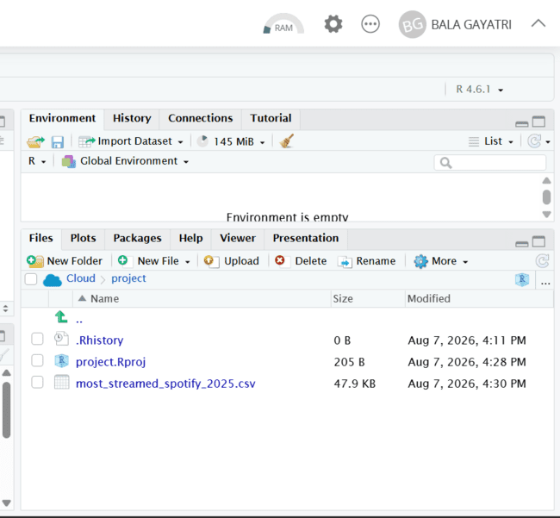
Figure 1. RStudio showing the most_streamed_spotify_2025.csv Spotify dataset.

7.2 Inspecting the First Records
head(spotify)
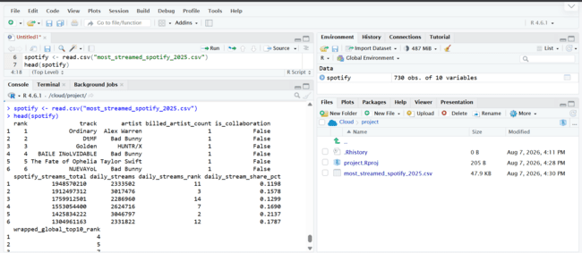
Figure 2. RStudio output showing the Head of the processed Spotify dataset.

7.3 Checking Dataset Structure
str(spotify)
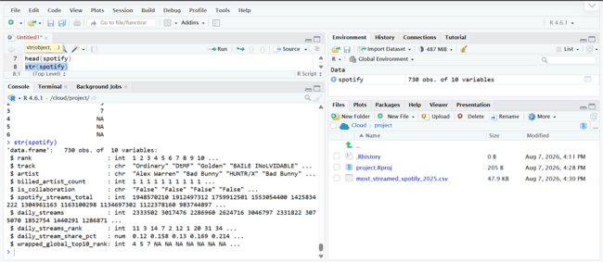
Figure 3. RStudio output showing the structure of the processed Spotify dataset.

The structure check confirmed that the dataset contained 730 observations. After removing the high-missingness ranking field, the working dataset contained 9 variables. The output also showed the numerical and encoded variables used during preprocessing.

7.4 Summary Statistics
summary(spotify)
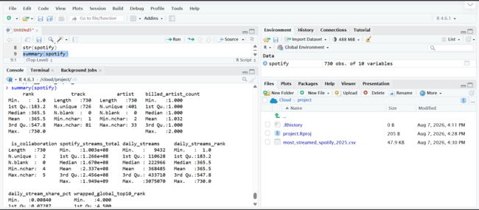
Figure 4. RStudio summary statistics for the cleaned/preprocessed dataset.
The summary() function provided minimum, quartile, median, mean and maximum values for numeric variables. It also confirmed the distribution of ranking, artist counts, collaboration indicators and normalized streaming variables.
7.5 Dataset Dimensions and Column Names
dim(spotify)
names(spotify)
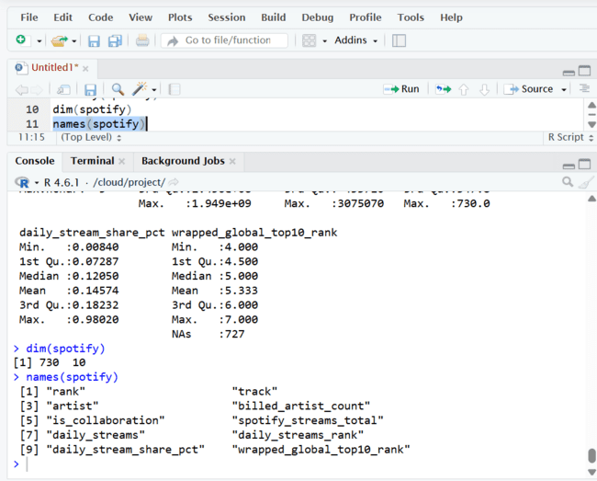
Figure 5. RStudio dimentions and column names statistics for the cleaned/preprocessed dataset

The final working dataset contains 730 rows and 9 columns.

8. Data Cleaning
8.1 Missing-Value Detection
colSums(is.na(spotify))
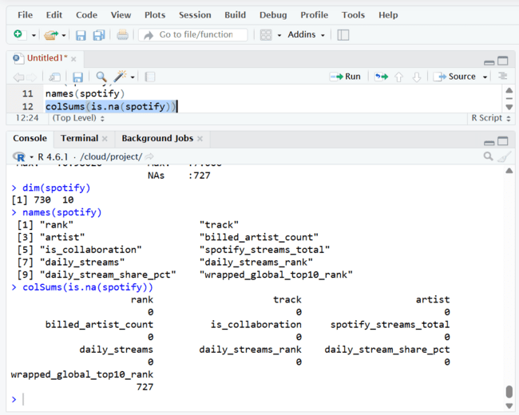

Figure 6. RStudio output showing the missing-value check. All retained variables show zero missing values.

Missing values were checked using colSums(is.na()). The original dataset contained extensive missingness in `wrapped_global_top10_rank`. Because this field was populated for only a very small number of records, imputing it would have introduced little useful information.

8.2 Removing the High-Missingness Column
spotify <- spotify %>%
select(-wrapped_global_top10_rank)
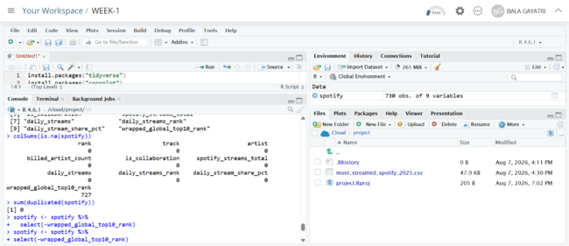
Figure 7. RStudio output showing the Removing the High-Missingness Column

The high-missingness column was removed rather than imputed. This decision reduced noise and prevented a largely empty variable from affecting later analysis.
8.3 Duplicate Check
sum(duplicated(spotify))
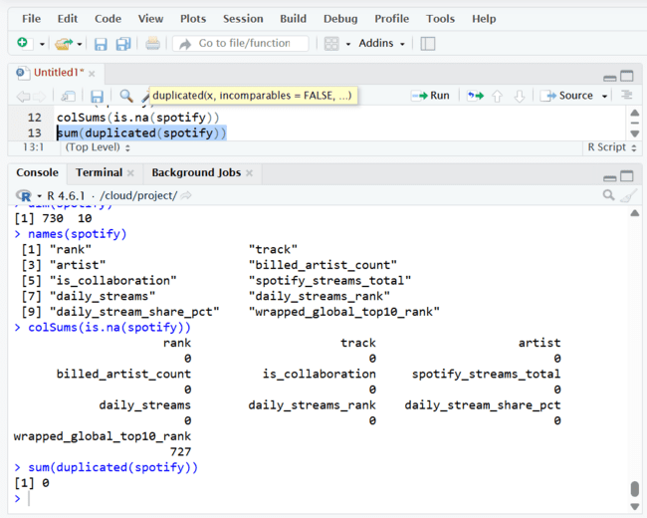
Figure 8. RStudio output showing the duplicate-row count.

Duplicate records were checked before continuing with analysis. If the output is 0, the report should state that no duplicate rows were found. If a non-zero value appears in your R session, update this sentence to report the exact count.
8.4 Missing Values After Cleaning
colSums(is.na(spotify))
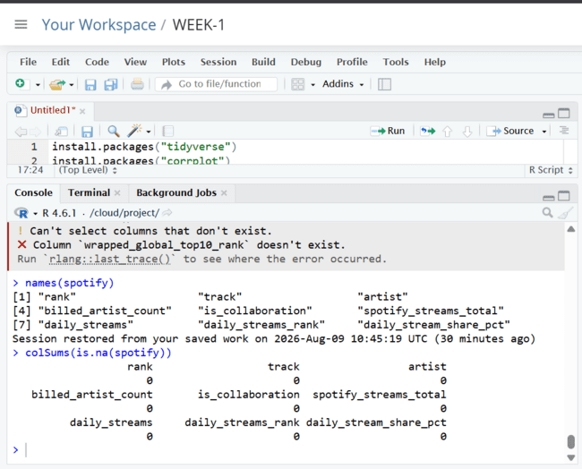
Figure 9. RStudio output showing the Missing values after Cleaning.

The final missing-value check showed zero missing values across the nine retained variables, confirming that the working dataset was complete for the subsequent preliminary analysis.
9. Data Preprocessing and Transformation
9.1 Outlier Detection
Streaming data can contain extreme observations because a small number of songs may be much more popular than the rest. Boxplots were used to visually inspect the distributions of total and daily streams.
boxplot(spotify_original$spotify_streams_total,
main = "Boxplot of Total Spotify Streams")
boxplot(spotify_original$daily_streams,
main = "Boxplot of Daily Streams")

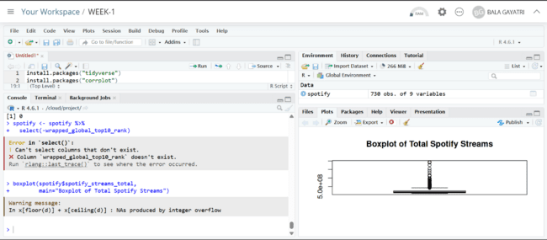
Figure 10. RStudio output showing the Boxplot of Total Spotify Streams
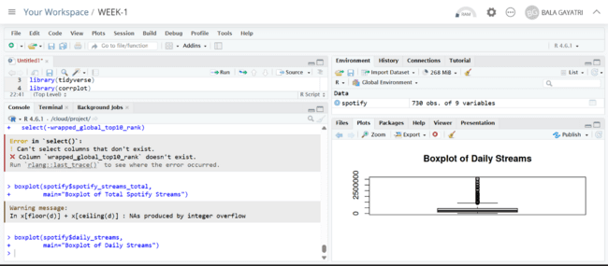
Figure 11. RStudio output showing the Boxplot of Daily Streams.

The extreme values were treated as potential genuine popularity observations rather than automatically deleted. In music-streaming data, an unusually high stream count can be a real business signal. Therefore, outlier detection was documented without assuming that every extreme observation was an error.
9.2 Normalization
spotify$spotify_streams_total <- scale(spotify$spotify_streams_total)
spotify$daily_streams <- scale(spotify$daily_streams)
spotify$daily_stream_share_pct <- scale(spotify$daily_stream_share_pct)

Standardization using scale() was applied to the principal continuous streaming variables. This transformation centers each variable around zero and scales it according to its standard deviation. Normalization is useful when variables have very different numerical magnitudes.
9.3 Converting Scaled Columns to Numeric Vectors
spotify$spotify_streams_total <- as.numeric(spotify$spotify_streams_total)
spotify$daily_streams <- as.numeric(spotify$daily_streams)
spotify$daily_stream_share_pct <- as.numeric(spotify$daily_stream_share_pct)

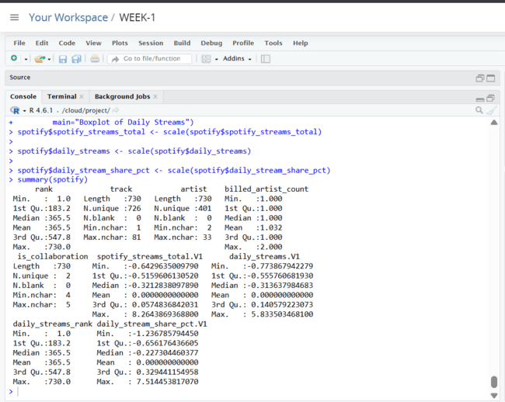
Figure 12. RStudio output showing the Final str(spotify) after converting scaled columns to numeric vectors.

Because scale() can return a matrix-like object, the transformed columns were converted back to ordinary numeric vectors using as.numeric(). This keeps the final data frame clean and easier to use.

9.4 Encoding Categorical Variables
spotify$is_collaboration <- as.numeric(as.factor(spotify$is_collaboration))
spotify$artist <- as.numeric(as.factor(spotify$artist))
spotify$track <- as.numeric(as.factor(spotify$track))
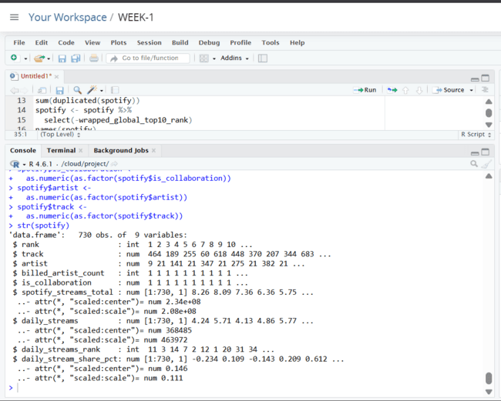
Figure 13. RStudio output showing the Final str(spotify) after Encoding Categorical Variables.

Categorical variables were converted into numeric codes using factor() followed by as.numeric(). This was sufficient for the preliminary preprocessing task. For a future predictive model, one-hot encoding or another encoding strategy would generally be preferable for high-cardinality variables such as artist and track because their numeric labels do not represent an ordinal relationship.

10. Exploratory Data Analysis
10.1 Daily Stream Distribution
hist(spotify$daily_streams,
main = "Distribution of Daily Streams",
xlab = "Daily Streams")
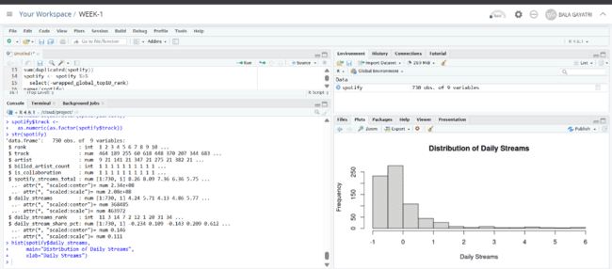
Figure 14. RStudio output showing Histogram of Daily Streams.

10.2 Collaboration Distribution
table(spotify_original$is_collaboration)
ggplot(spotify_original,
aes(x = is_collaboration)) +
geom_bar() +
labs(title = "Distribution of Solo Songs and Collaborations",
x = "Collaboration",
y = "Number of Songs")
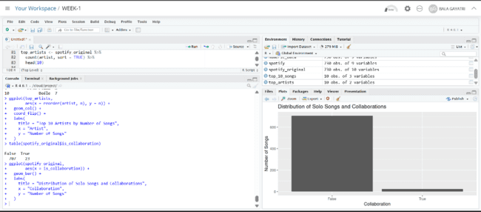
Figure 15. RStudio output showing Collaboration bar chart.

The observed counts were 707 non-collaboration songs and 23 collaboration songs. Thus, collaborations represented a relatively small portion of the dataset.
10.3 Top 10 Most Streamed Songs
top_10_songs <- spotify_original %>%
arrange(desc(spotify_streams_total)) %>%
select(track, artist, spotify_streams_total) %>%
head(10)
top_10_songs 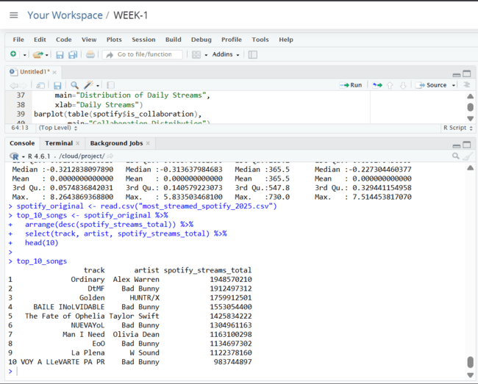

Figure 16. Top 10 most-streamed songs from the Spotify 2025 dataset.

The top-ranked song in the dataset was "Ordinary" by Alex Warren with 1,948,570,210 streams. Bad Bunny appeared multiple times among the top 10, indicating a strong presence in the dataset's highest-streaming group.
10.4 Top 10 Artists by Number of Songs
top_artists <- spotify_original %>%
count(artist, sort = TRUE) %>%
head(10)
top_artists 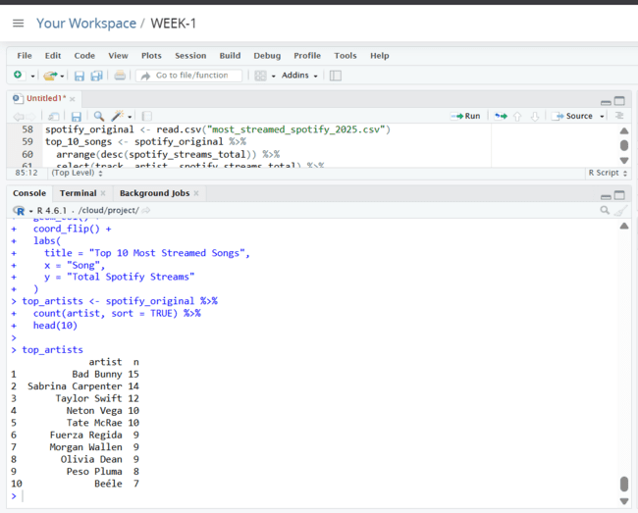

Figure 17. Top 10 artists by number of songs represented in the dataset.
Bad Bunny had the highest number of songs in the dataset, with 15 entries, followed by Sabrina Carpenter with 14 and Taylor Swift with 12. This indicates that a relatively small group of artists has substantial representation in the 2025 most-streamed collection.
10.5 Top 10 Artists Visualization
ggplot(top_artists,
aes(x = reorder(artist, n), y = n)) +
geom_col() +
coord_flip() +
labs(title = "Top 10 Artists by Number of Songs",
x = "Artist",
y = "Number of Songs")
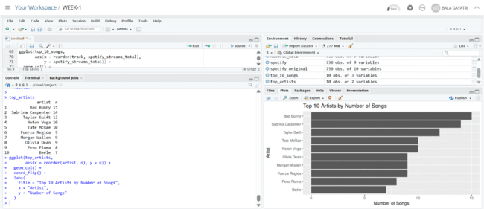
Figure 18. Top 10 artists by Visualization.

10.6 Top 10 Songs Visualization
ggplot(top_10_songs,
aes(x = reorder(track, spotify_streams_total),
y = spotify_streams_total)) +
geom_col() +
coord_flip() +
labs(title = "Top 10 Most Streamed Songs",
x = "Song",
y = "Total Spotify Streams")
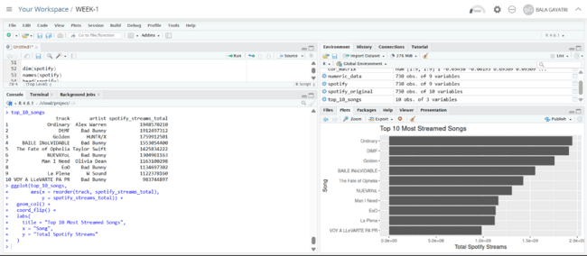
Figure 19. Top 10 Most Streamed Songs by Visualization.

10.7 Daily Streams vs Total Streams
ggplot(spotify_original,
aes(x = daily_streams,
y = spotify_streams_total)) +
geom_point() +
labs(title = "Daily Streams vs Total Spotify Streams",
x = "Daily Streams",
y = "Total Spotify Streams")
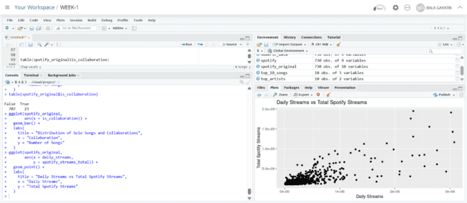
Figure 20. Scatter plot of Daily Streams vs Total Spotify Streams.

11. Correlation Analysis
cor(spotify_original$daily_streams,
spotify_original$spotify_streams_total,
use = "complete.obs")
Actual output obtained in R:
[1] 0.7795761
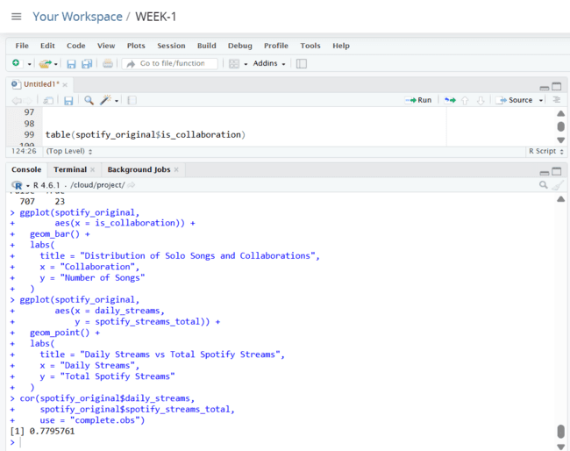
Figure 21. RStudio output showing the correlation coefficient of 0.7795761.

The correlation coefficient of 0.7795761 indicates a strong positive linear association between daily streams and total Spotify streams. In general, songs with higher daily streaming activity tend to have higher accumulated total streams.

11.1 Correlation Matrix and Heatmap
numeric_data <- spotify %>%
select(where(is.numeric))
cor_matrix <- cor(numeric_data)
corrplot(cor_matrix,
method = "color")

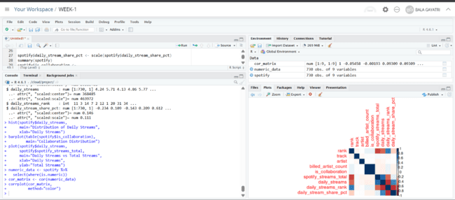
Figure 22. RStudio output showing the Correlation heatmap generated with corrplot.

12. Initial Findings and Insights
The working dataset contained 730 observations and 9 variables after removing the high-missingness ranking field.
The high-missingness `wrapped_global_top10_rank` variable was removed because it contained very little usable information.
The final missing-value check showed zero missing values across the retained variables.
The dataset contains substantial variation in streaming measures, making outlier detection important.
The streaming variables were standardized to make their scales more comparable for downstream analysis.
The collaboration analysis showed 707 non-collaboration songs and 23 collaboration songs, indicating that collaborations were a relatively small subset.
The most-streamed song in the observed dataset was "Ordinary" by Alex Warren with 1,948,570,210 streams.
Bad Bunny had the highest number of songs represented in the dataset, with 15 entries.
The correlation between daily streams and total Spotify streams was 0.7795761, showing a strong positive relationship.

12.1 Analytical Interpretation
The preliminary analysis suggests that streaming success is concentrated among a relatively small set of songs and artists. The strong relationship between daily and accumulated streams is expected because sustained daily listening contributes directly to total streams. However, correlation alone does not establish causation, and additional analysis would be required to identify factors that drive streaming performance.

13. R Code Appendix
The following code represents the main workflow used in the analysis.
# Packages
install.packages("tidyverse")
install.packages("corrplot")
library(tidyverse)
library(corrplot)
# Import
spotify <- read.csv("most_streamed_spotify_2025.csv")
# Initial inspection
head(spotify)
str(spotify)
summary(spotify)
dim(spotify)
names(spotify)
# Missing values and duplicates
colSums(is.na(spotify))
sum(duplicated(spotify))
# Remove high-missingness column
spotify <- spotify %>%
select(-wrapped_global_top10_rank)
# Normalization
spotify$spotify_streams_total <- scale(spotify$spotify_streams_total)
spotify$daily_streams <- scale(spotify$daily_streams)
spotify$daily_stream_share_pct <- scale(spotify$daily_stream_share_pct)
# Convert scaled columns to numeric vectors
spotify$spotify_streams_total <- as.numeric(spotify$spotify_streams_total)
spotify$daily_streams <- as.numeric(spotify$daily_streams)
spotify$daily_stream_share_pct <- as.numeric(spotify$daily_stream_share_pct)
# Categorical encoding
spotify$is_collaboration <- as.numeric(as.factor(spotify$is_collaboration))
spotify$artist <- as.numeric(as.factor(spotify$artist))
spotify$track <- as.numeric(as.factor(spotify$track))
# Outlier detection
boxplot(spotify_original$spotify_streams_total,
main = "Boxplot of Total Spotify Streams")
boxplot(spotify_original$daily_streams,
main = "Boxplot of Daily Streams")
# Exploratory analysis
hist(spotify$daily_streams,
main = "Distribution of Daily Streams",
xlab = "Daily Streams")
table(spotify_original$is_collaboration)
# Top 10 songs
spotify_original <- read.csv("most_streamed_spotify_2025.csv")
top_10_songs <- spotify_original %>%
arrange(desc(spotify_streams_total)) %>%
select(track, artist, spotify_streams_total) %>%
head(10)
# Top artists
top_artists <- spotify_original %>%
count(artist, sort = TRUE) %>%
head(10)
# Correlation
cor(spotify_original$daily_streams,
spotify_original$spotify_streams_total,
use = "complete.obs")
numeric_data <- spotify %>%
select(where(is.numeric))
cor_matrix <- cor(numeric_data)
corrplot(cor_matrix, method = "color")
# Save cleaned dataset
write.csv(spotify, "spotify_cleaned.csv", row.names = FALSE)

14. Conclusion
The Week 1 objective of performing data cleaning, preprocessing and preliminary analysis in R was completed. The Spotify 2025 dataset was imported, inspected and cleaned. Missing values were identified and the highly incomplete ranking field was removed. Duplicate records were checked, numerical variables were standardized, and categorical variables were encoded for preprocessing.
Exploratory analysis was then performed using summary statistics, distribution plots, bar charts, top-song and top-artist analysis, scatter plots and correlation analysis. The results produced several useful initial insights, including the strong positive relationship between daily and total streams and the concentration of songs among a small number of artists.
The cleaned dataset is suitable for further analysis in later internship tasks, such as predictive modeling, artist-level analysis, popularity prediction or deeper statistical investigation.

